Personalising healthcare for patients with Diabetes

This is an unusual post as what started out as a project to showcase data science skillsets in addressing a clinical problem I frequently encounter, ended as a conclusion on personalising healthcare with the bulk of my recommendations not at all based on the project outputs. Confused much? I don’t blame you.

The reason(s) behind this is(are) quite simple: -

- I am a practising clinician by background and chose the problem to address based on personal experience of managing patients with diabetes requiring emergency care provision (due to complications)
- I am a data scientist motivated to leverage my tech skills to address problems I/colleagues face in clinical practice
- The legacy (old) datasets chosen for this project (from the UCI Machine Learning Repository) were great in that they required lots (& lots) of data cleaning and exploratory work (not dissimilar to the daily practice of data science practitioners) but not so great wrt features they actually contained, on which I trained and tested my models.
So, my model outputs were a bit crap (but don’t let this deter you, the proof here is in the (creation of) the pudding! The objective here is therefore a focus on process rather than on actual results/outputs. Datasets with more relevant feature inputs are essential for models with actionable outputs.

Diabetes mellitus as a condition is a misnomer in that it encompasses a variety of several different conditions (of varying genetic and environmental influences) which results in diseases of differing levels of severity in different individuals.

There are approximately 3.5 million patients with diabetes currently living in the UK. Diabetes alone accounts for approximately 10,000 amputations each year (leg, toe or foot).
1 in 6 patients admitted to hospital has diabetes and patients with diabetes are twice as likely to be admitted to hospital (1). There are also cardiac, renal, metabolic and other consequences for patients with poor diabetes control.

The specific focus of the project was on identification of patients with diabetes (that’s right, not “diabetic patients”, more on that later), at risk of an avoidable hospital admission due to their condition in the short term (3 - 6 months). This time period was chosen as patients should typically be followed up every 3- 6 months for diabetes management (either within the primary or secondary care system).

Data Analysis
As mentioned, the data was restricted in terms of the features actually present (regular/intermediate insulin doses and blood glucose levels measured pre-breakfast, pre-lunch, pre-supper + unspecified blood glucose results). Other feature inputs that would serve to greatly improve the outputs of my models include HbA1c levels (measure of average blood glucose levels over previous 3 months), creatinine clearance and eGFR (as a measure of kidney function), the frequency of patient admissions due to diabetic complications (emergency and otherwise), frequency of no-shows to routine follow-ups, social and other determinants of health etc.

A deep dive into datasets from a single patient permitted a descriptive data analysis of the types of insulin values (and the frequencies of their use) as well as the intervals for glucose checks. This didn’t yield much excitement besides a more frequent use of regular (33) vs intermediate (34) insulin and the patient most frequently checked their blood glucose levels at pre-breakfast (58) times (yay!).

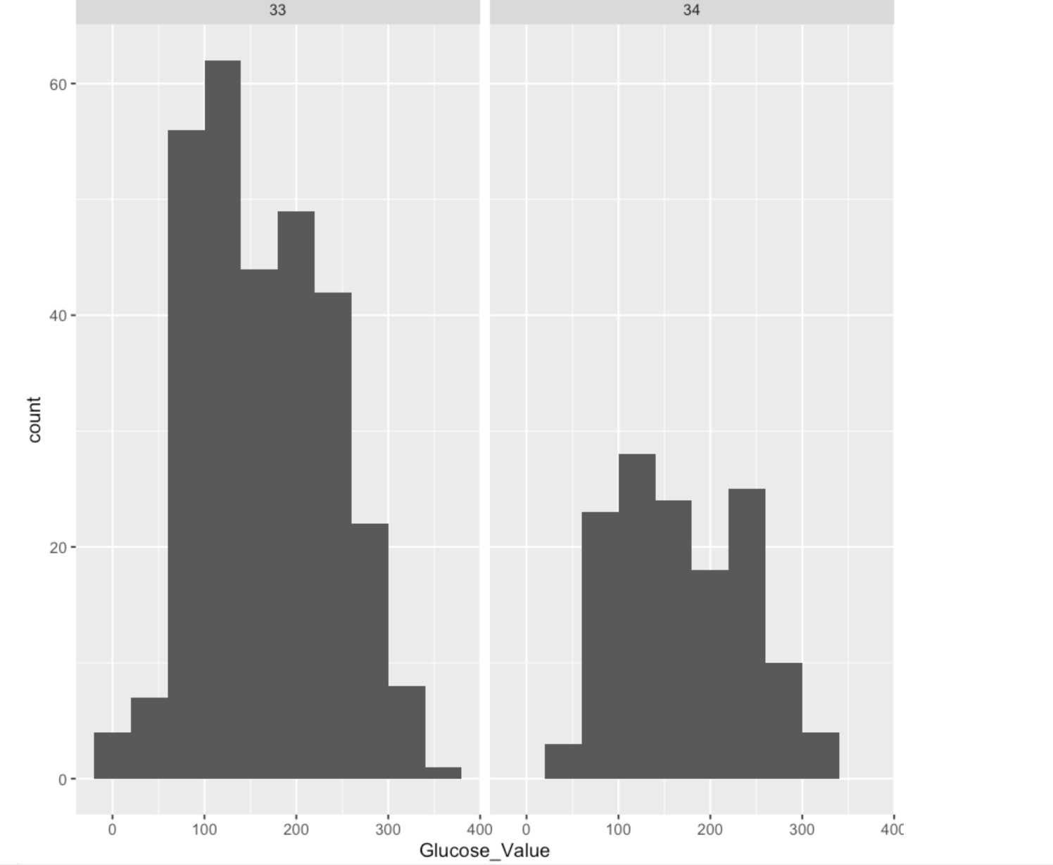

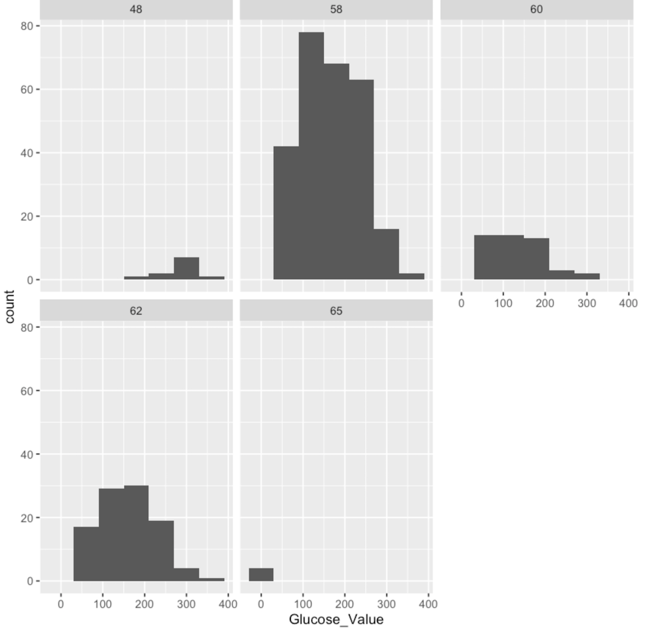

I next undertook an Inferential Cohort Analysis of the data (in a nutshell, we do some analysis to obtain conclusions beyond the immediate data outputs alone). This was done using a dependent t-test statistic, using a statistical significance/p-value of 0.05. This p-value (or lower) was never achieved, and it was therefore concluded that there was no statistically significant monthly change in the average blood glucose levels of the patient within the time period covered by the datasets.

Model development
Different techniques were used: -
- Supervised learning (e.g., Regression, Classification)
- Unsupervised learning (e.g., Clustering) and
- Time Series Analysis and Forecasting to address the problem statement in different ways.

I built regression models (Linear, Random Forest and GLM NET) to predict (solid green squares below) numerical values of blood glucose levels which was compared to the actual numerical blood glucose values present in the data. As mentioned, the model outputs were not great/accurate due to input data quality.

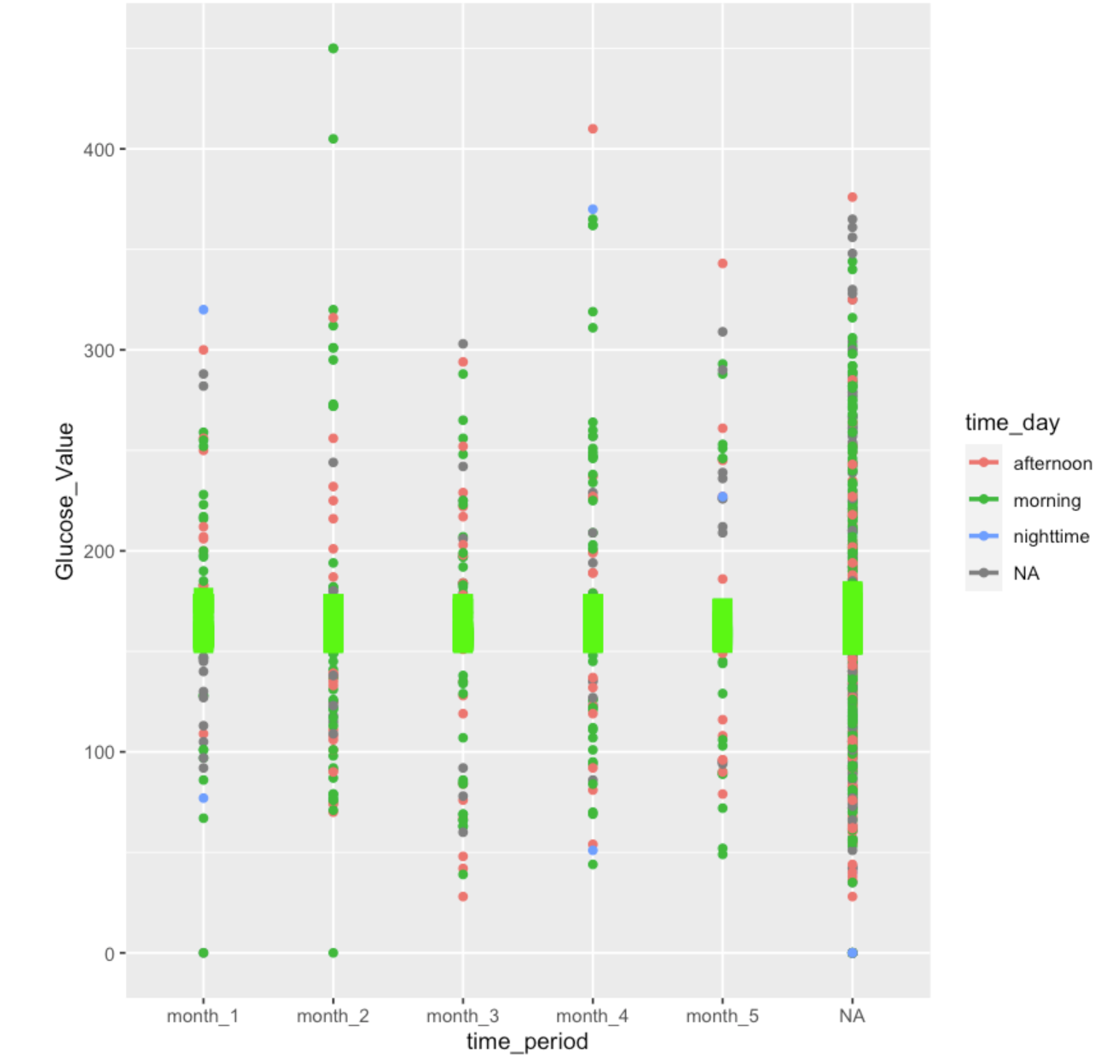

I next built Classification models (logistic regression, Random Forest and Gradient Boost) to predict which of 2 classes (poor glucose control i.e., <40 or >200mg/dL) or normal glucose control (40 - 200mg/dL) each patient would belong.

A Confusion Matrix was constructed to compare the model’s predicted classes against actual classes & showed most data points were either correctly predicted as true positives (1026) or true negatives (409) with only 16 incorrectly predicted as false negatives.

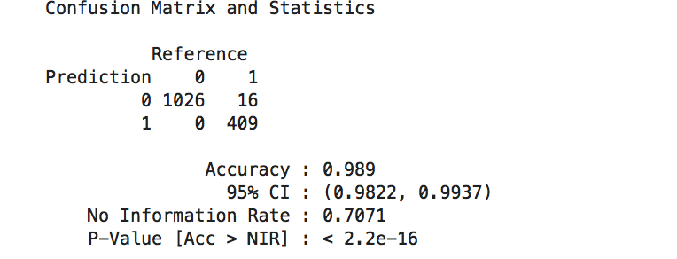

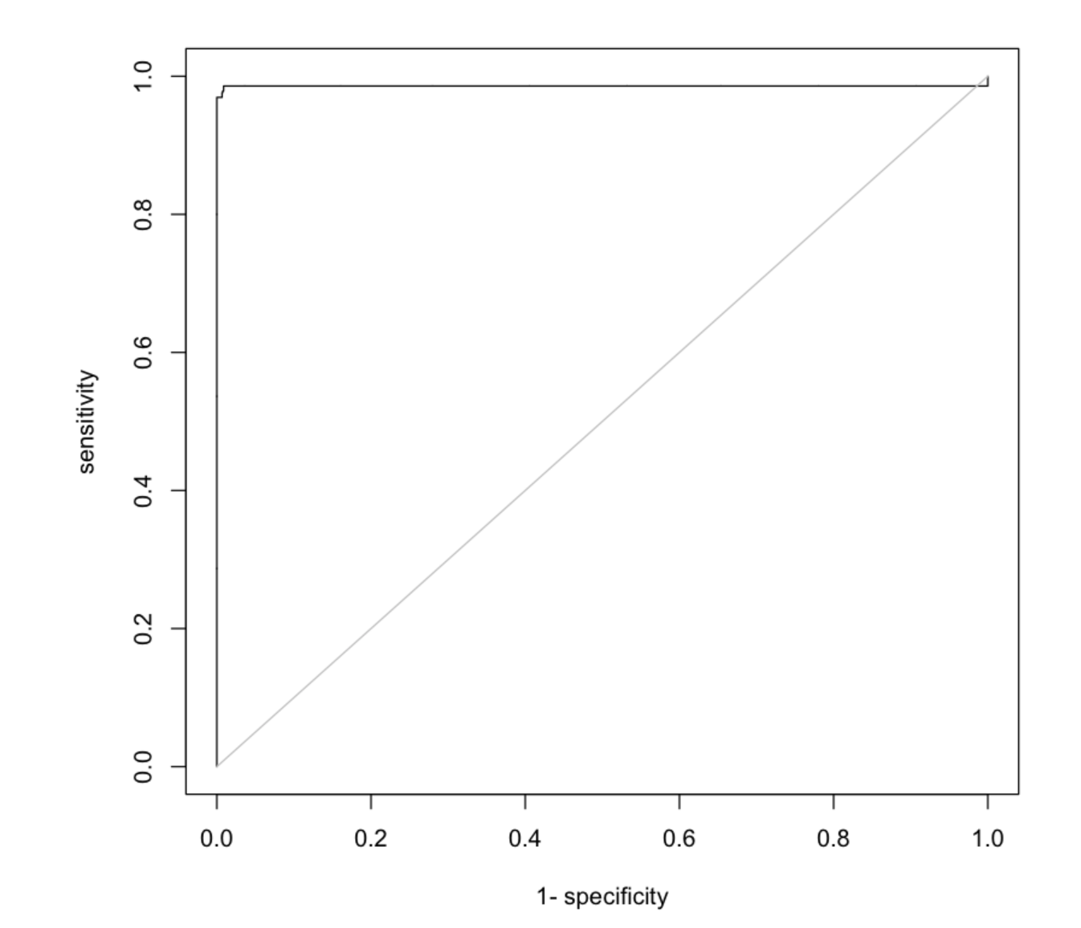

I next used an Unsupervised (k-means) clustering model to group clusters of Diabetic patients along similar characteristics that were not pre-defined. A comparison of subsequent rounds of clustering showed output patient clusters of different sizes and distributions. The implication here being that the groups within each cluster were likely not made up of similar patient characteristics (in normal English speak, the colour distributions in the 2 graphs below are different).

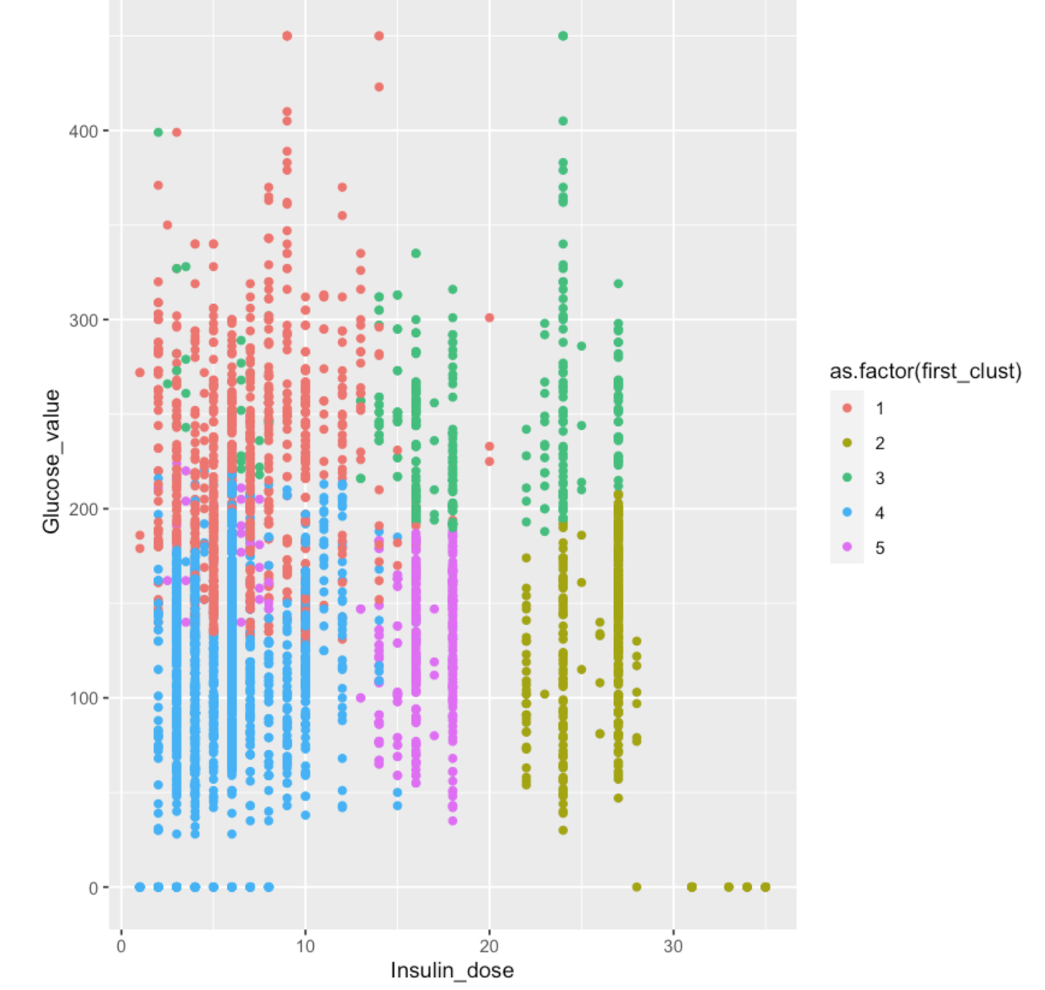

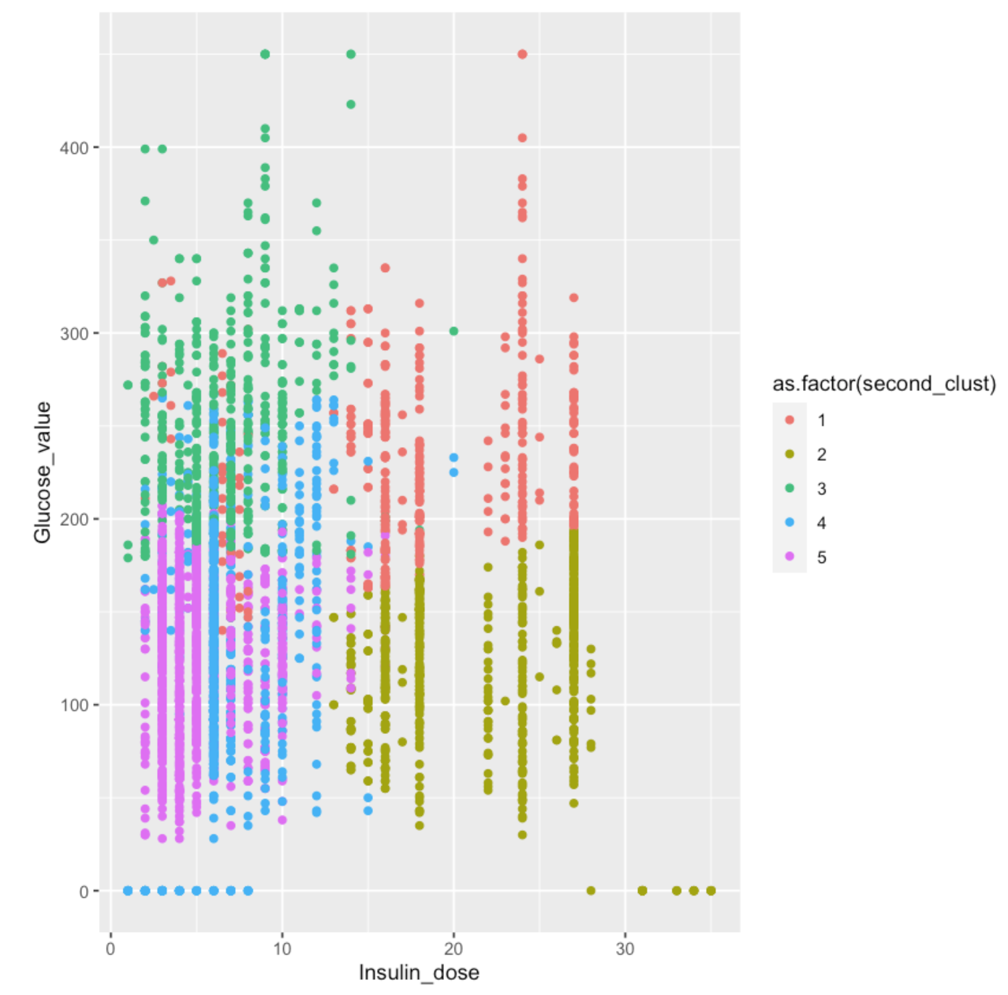

Finally, Time series models (naive Bayes, random and automatic ARIMA as well as Prophet) were developed to forecast blood glucose values over time (migrating beyond static forecasts typical of predictive analytics).

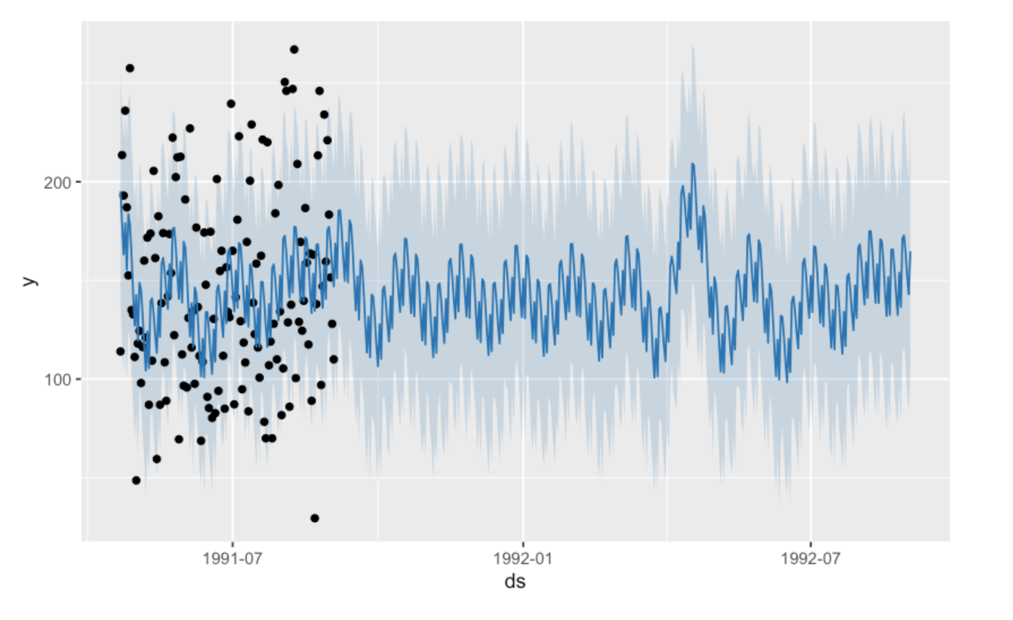

So What? /Outcome

Above was all very well and good. The process was outlined to give a walkthrough of this clinician’s approach to addressing the current challenge associated with early identification of at-risk patients with diabetes. The actual model outputs were not actionable (and would require better quality data inputs for actionable insights).
The point of this was to showcase the potential of AI/ML as tech enablers in addressing this problem.

Recall I mentioned at the start that my conclusion on personalising healthcare for patients had nothing to do with the (crap) outputs from the models?

Diabetes mellitus as a chronic condition lends itself well to the model of a personalised treatment approach for people living with the disease condition.

The potential for delivery of personalised/precision medicine is possible as ML is able to handle complex data encompassing individual patient genetics, risk profiles, individual response to treatments etc. This permits the development of a targeted treatment recommendation specific to each individual.

In as much as technology can be used to encompass unique patient characteristics and predict optimal treatment regimens and dosing intervals (which solves the problem of care provision responsive to individual need), technology used in this way can however not address patient self-motivation. If patients with diabetes don’t take their diabetic meds as prescribed or attend their routine consultations, the outcome is a no-brainer. This mindset shift is essential for the successful long-term self-management of chronic conditions to which the health system is currently not adapted to support. The difference between a patient that is compliant with their diabetic medication and lifestyle changes because “the dr told them to do so” vs an intrinsic interest in the lifestyle and other changes that will keep them healthy long-term. This also further highlights the point made about distinguishing between a “diabetic patient” and a “person with diabetes”. Patients with diabetes are people first and foremost. They happen to live with a chronic condition which the health system/society should not use to define them. It is likely that on occasion, we aka the health system, could do more to engage patients in becoming active participants in improving their own health outcomes.

This is extremely crucial in personalising healthcare for patients required to commit to a lifetime (in most cases) of self-management of their chronic disease conditions like Diabetes, which may have no cure.

Stay healthy and motivated.

I am a clinician and a data scientist, passionate about leveraging my tech skillsets to improve patient outcomes and experience of health along their journey.

